DAY-12 (25/6/2025)
Emp ID : 110714877
NAME :Kinnera venkatamma

Task 1: What is the binary 8 bit representation of A?

ANS : A- 65
01000001 -8 Bit BINARY value
Task 2: What is the binary value of a?

ANS : a-97
01100001 -8 Bit binary value
Task3. Types of Computer memory with examples.. Explain ..

Computer memory can be broadly classified into
1. primary memory (RAM and ROM) and
2. secondary memory (like hard drives and SSDs).
Primary memory provides fast access to data currently in use, while secondary memory offers long-term storage.
Primary Memory:
RAM (Random Access Memory):
This is volatile memory, meaning it loses its data when the power is turned off. It's used to store data and instructions that the CPU is actively using.
ROM (Read-Only Memory):
This is non-volatile memory, meaning it retains data even without power. It typically contains the computer's startup instructions (BIOS).
Cache Memory:
A small, very fast memory located close to the CPU, used to store frequently accessed data for quicker retrieval.
Secondary Memory:
Hard Disk Drives (HDDs): Traditional storage devices that use magnetic platters to store data. They offer large storage capacity at a lower cost.
Solid State Drives (SSDs): More modern storage devices that use flash memory, offering faster access speeds and greater durability compared to HDDs.
Other examples: CD-ROMs, DVDs, and USB flash drives are also forms of secondary memory.
In simpler terms: Imagine RAM as your desk where you keep the documents you're currently working on. When you turn off your computer, you lose everything on your desk (volatile). ROM is like a reference book that you always need to boot up your computer (non-volatile). Secondary memory is like a filing cabinet where you store all your other documents and projects.
Task4. What you do understand by data structures..?

Data structure is storing our data in a structured manner for quick access/modification purpose
Task5 .What are the operations on data structures ?

We can perform Operations:
Searching
Sorting
Insert
Delete
Traversing
Merge

Task 6: What are static and dynamic arrays key points summarize in a table

Feature | Static Array | Dynamic Array
Size | Fixed at compile time | Changeable at runtime
Memory Allocation | Stack | Heap
Resizing | Not allowed | Allowed
Flexibility | Less flexible | More flexible
Memory Efficiency | May waste memory | Can be more efficient

Task 7: Reverse an array. write a code.

class Main {
static void reverseArray(int arr[]) {
int start = 0, end = arr.length - 1;
while (start < end) {
int temp = arr[start];
arr[start] = arr[end];
arr[end] = temp;
start++;
end--;
}
}

public static void main(String[] args) {
int arr[] = {1, 2, 3, 4, 5};
reverseArray(arr);
for (int i = 0; i < arr.length; i++) {
System.out.print(arr[i] + " ");
}
}
}
Output
5 4 3 2 1

Task 8: Reverse a string .. write a code.

// Java Program to Reverse a String
// Using for loop
import java.util.Scanner;
class ReverseofaString
{
public static void main(String[ ] arg)
{
String str;
Scanner scan=new Scanner(System.in);
System.out.print("Enter a string : ");
str=scan.nextLine();
char[] ch=str.toCharArray();
System.out.println("Reverse of a String is :");
int j=ch.length;
for(int i=j;i>0;i--)
{
System.out.print(ch[i-1]);
}
}
}
Output : arenniK

Task 10: What is the code snippet doing..?

public class Example {
public static void main (String[] args) {
int[] arr1 = {11, 34, 66, 75};
int n1 = arr1.length;
int[] arr2 = {1, 5, 19, 50, 89, 100};
int n2 = arr2.length;
int[] merge = new int[n1 + n2];
int i = 0, j = 0, k = 0, x;
System.out.print("Array 1: ");
for (x = 0; x < n1; x++)
System.out.print(arr1[x] + " ");
System.out.print("\nArray 2: ");
for (x = 0; x < n2; x++)
System.out.print(arr2[x] + " ");
while (i < n1 && j < n2) {
if (arr1[i] < arr2[j])
merge[k++] = arr1[i++];
else
merge[k++] = arr2[j++];
}
while (i < n1)
merge[k++] = arr1[i++];
while (j < n2)
merge[k++] = arr2[j++];
System.out.print("\nArray after merging: ");
for (x = 0; x < n1 + n2; x++)
System.out.print(merge[x] + " ");
}
}
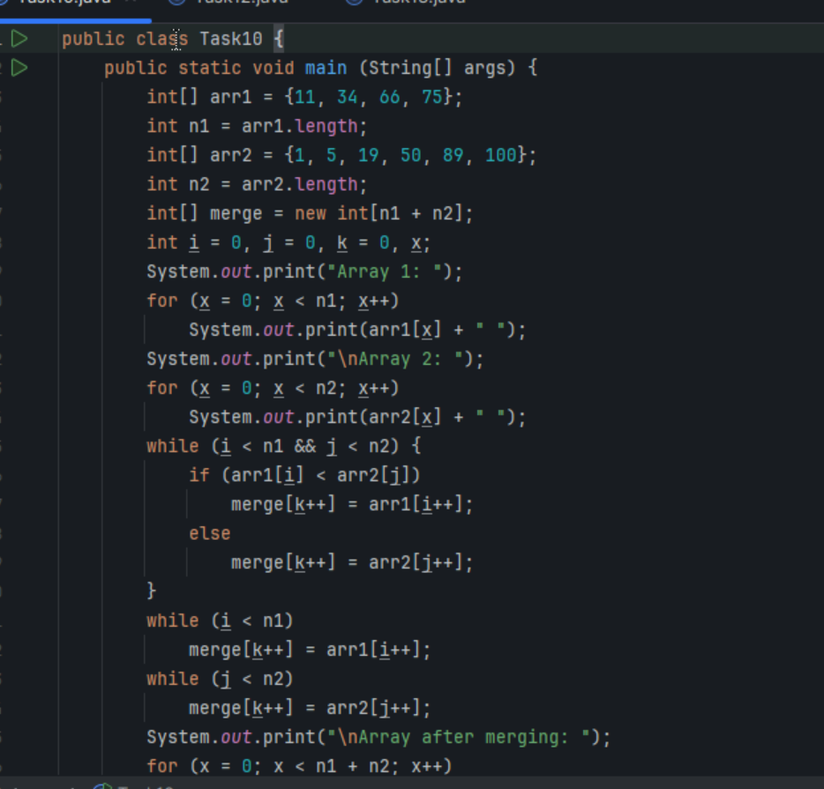
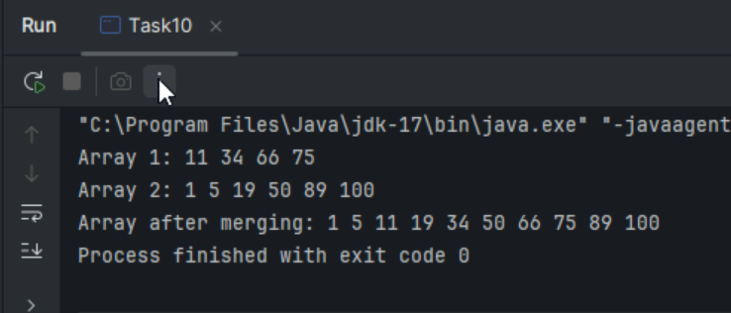

Task 11:What do you know about hash table?

A hash table is a data structure that implements an associative array, mapping keys to values using a hash function to compute an index into an array.

This allows for very fast average-case lookup, insertion, and deletion of key-value pairs.

Task 12:

Wap to create a hash table and display them..

import java.util.Hashtable;
import java.util.Map;

public class Task012_DS_HashTable {
public static void main(String[] args) {
Hashtable<String, Integer> ht = new Hashtable<>();
ht.put("Anitha", 101);
ht.put("Kavitha", 102);
ht.put("Meera", 103);

for (Map.Entry<String, Integer> e : ht.entrySet())
System.out.println(e.getKey() + " " + e.getValue());
}
}
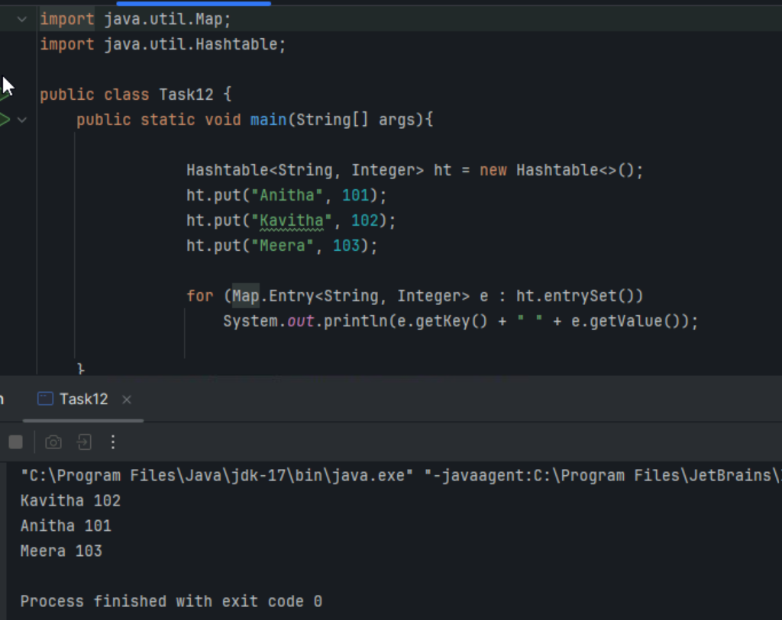

Task 13:
Wap to create a hash map and display them..

import java.io.*;
import java.util.*;

class Task013_DS_HashMap {

public static void main(String args[]) {
HashMap<Integer, String> hmobj1 = new HashMap<>();

HashMap<Integer, String> hmobj2 = new HashMap<Integer, String>();

hmobj1.put(10, "Anitha");
hmobj1.put(20, "Saritha");
hmobj1.put(30, "Ankitha");

hmobj2.put(44, "John");
hmobj2.put(55, "Steve");
hmobj2.put(66, "Jack");

System.out.println("Mapping HashMap hmobj1: " + hmobj1);

System.out.println("Mapping HashMap hmobj2: " + hmobj2);
}
}

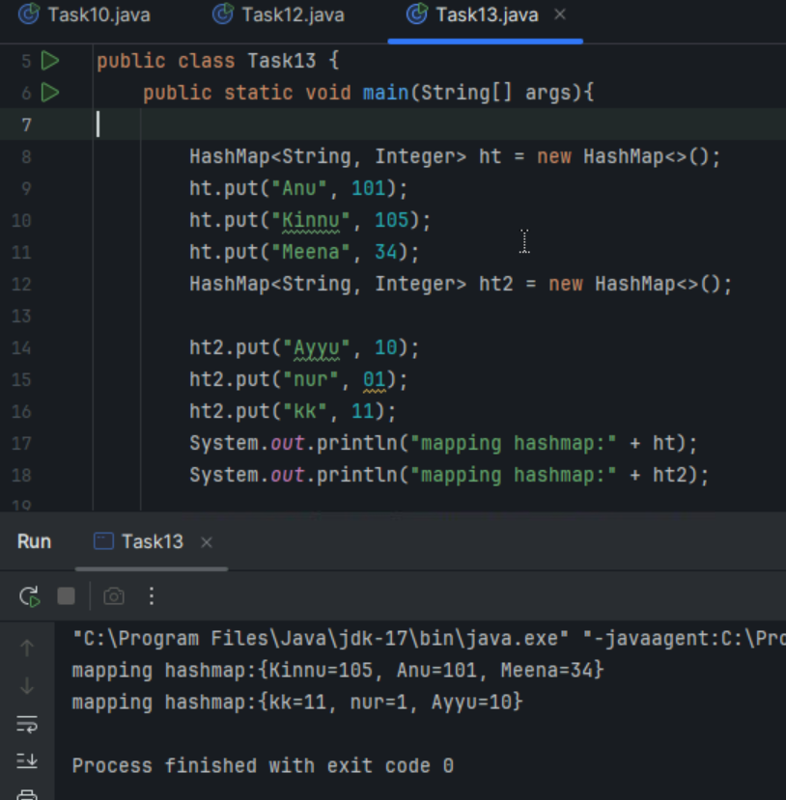
//set -- arrayList , replace the values , updates the previous value
//put -- hash table , insert the value, puts a new value

Task 14: Hash table advantages and disadvantages

Advantages | Disadvantages
Fast lookup, insertion, and deletion: Average case time complexity is O(1) for these operations | Collisions: When different keys hash to the same index, requiring collision resolution strategies
Efficient for large datasets: Performs well even with a large number of key-value pairs | Memory overhead: May require more memory than other data structures due to the need for hash functions and potential for empty slots
Dynamic resizing: Can automatically adjust its size as data increases or decreases | Lack of ordering: Hash tables generally don't maintain the order of elements, which can be a drawback in certain applications
Flexibility in key types: Can use a variety of data types as keys, not just integers | Dependency on hash function: Performance heavily relies on the quality of the hash function; a poorly designed hash function can lead to frequent collisions and slower performance
Good space utilization: With a good hash function and appropriate resizing, space is generally used efficiently | Worst-case scenarios: In the worst-case scenarios (e.g., all keys hash to the same index), performance degrades to O(n)
Simple and easy to implement: Generally easier to implement compared to some other complex data structures like trees | No inherent order: Not suitable for scenarios where the order of elements is important

Task15.

Task16.Methods of Hash table ?

It provide several methods for managing key-value pairs. Common methods include
put() for adding/updating entries,
get() for retrieving values,
remove() for deleting entries,
containsKey() and containsValue() for checking the existence of keys and values,
size() for the number of entries,
isEmpty() for checking if empty,
clear() for removing all entries, and
elements() and keys() for iterating through values and keys respectively.

Task18. Explain the internal working of a HashMap. With diagram..

A HashMap in Java efficiently stores key-value pairs using a combination of hashing and linked lists (or trees) to handle potential collisions.

When a key-value pair is added, the key's hashCode() method is used to determine a hash value.

This value, along with the current size of the HashMap, determines the index (or "bucket") where the data will be stored.
Collisions, where multiple keys map to the same index, are resolved using separate chaining, typically with a linked list or tree structure within that bucket.

Retrieving a value involves calculating the hash code of the key, finding the corresponding bucket, and then traversing the linked list (or tree) to find the matching key.

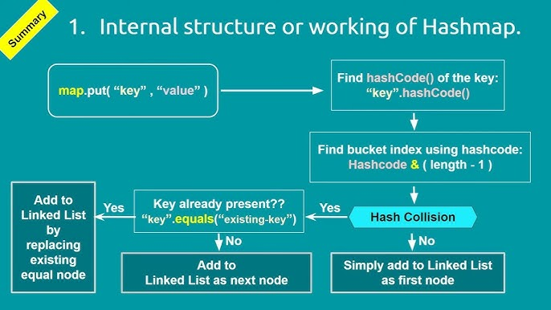

Task 19: Try to add 1 null value in the key and run the hash map code..

Also add one more null value to the key and see the result..
Sample 👍

import java.util.*;
import java.io.*;
public class Task019_Ds_HashMapNull {
public static void main(String[] args) {
HashMap hmap=new HashMap();
hmap.put(101,"Prasunamba");
hmap.put(null,"Meher");
hmap.put(null,".MK");
System.out.println(hmap);
}
}

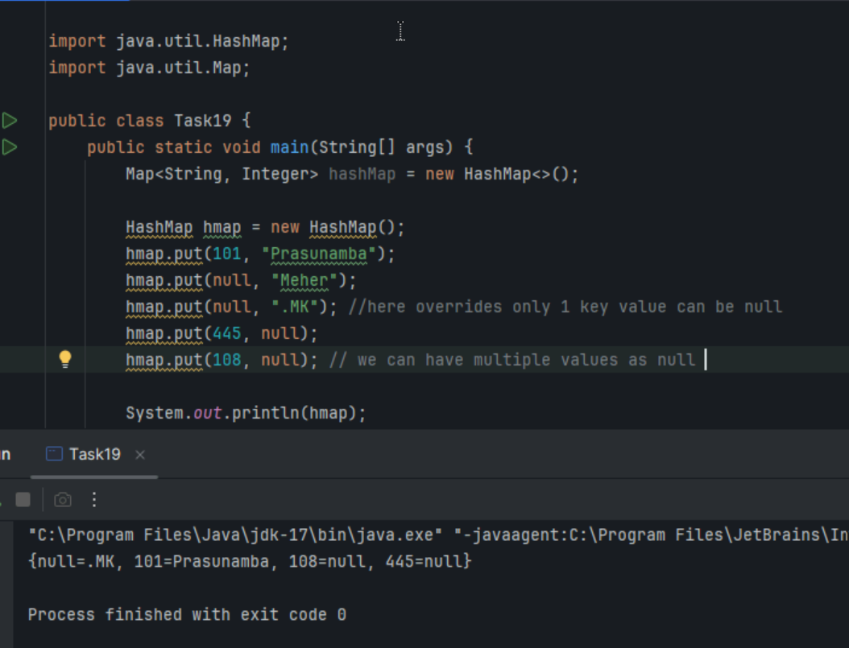

Task 20: How many methods are there to create a hash Map?

There are four ways to create a HashMap in Java using constructors.

1) Constructing a hashmap with default capacity

ex:
HashMap<String, Integer> hm1 = new HashMap<String, Integer>();

2) Constructing a hashmap with a capacity 10

ex:
HashMap<String, Integer> hm2 = new HashMap<String, Integer>(10);

3)copy one map to another map

ex:
HashMap<String, Integer> hm3 = new HashMap<String, Integer>( hm2);

4)
Specifying load factor along with the capacity

ex:
HashMap<String, Integer> hm4= new HashMap<String, Integer>(10, 0.75f);

Initial capacity ===10
Load factor === 0.75f

Task 21:

Wap to make a Hashmap synchronized..

Plz note : Hash Map are - asynchronous in nature..

import java.util.Collections;
import java.util.HashMap;
import java.util.Map;

public class task021_DS_HashMap_SyncMap {
public static void main(String[] args) {
HashMap<String, Integer> Hm1 = new HashMap<String, Integer>();
Map<String, Integer> syncMap = Collections.synchronizedMap(Hm1);
}
}

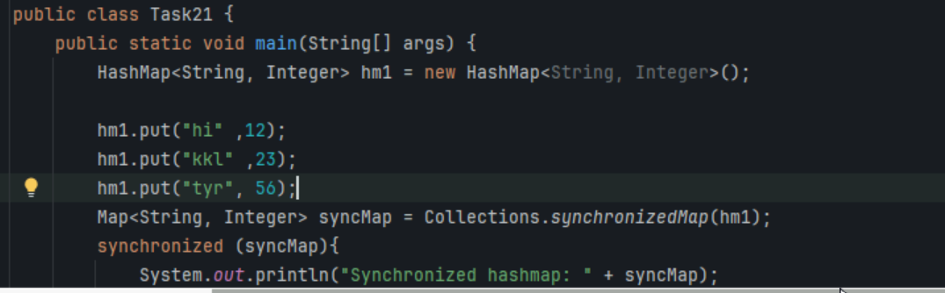
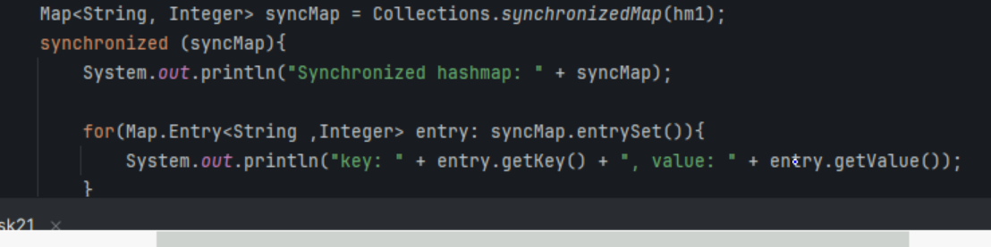
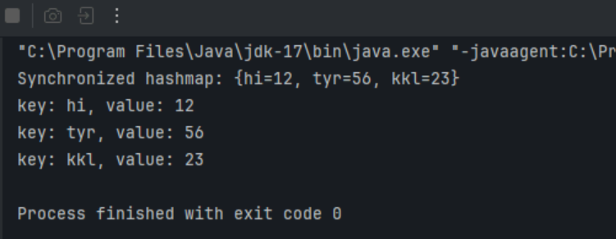
HOME TASKS:
Do hash table have linked list internally?

->Yes, HashMap (or hash table in java) does use a Linked List internally -but only in specific cases

Do collisions occur in hash Maps? What are they?

->Yes, Collision do occurs in HashMaps , and they are a key part of how hash – based data structures work.

Collision: two or more different keys map to the same bucket (value).

->What is load factor and how the capacity increases?

Load factor =(number of elements)/(capacity)

It’s calculated as the ration of the number of elements (key- value pairs) to the capacity(number of buckets or slots)

When the load factor exceeds a certain threshold(usually around 0.7 or 0.8) ,the data structure needs to increase its capacity to maintain efficient performance .This process is called resizing or rehashing .

